PROJECT REPORT
Contact Manager
A Secure, Full-Stack Contact Management Application
Built with React, Express.js, and MongoDB
MERN STACK · SESSION AUTHENTICATION · REST API

CONTENTS
Table of Contents
1. Introduction 3
1.1 Background 3
1.2 Problem Statement 3
1.3 Objectives 3
1.4 Scope and Limitation 4
2. Tech Stack 5
3. Core Modules 6
3.1 Main UI Modules 6
3.2 Main API Endpoints 8
4. Conclusion 10
5. References 11

SECTION 1

Introduction
The Contact Manager is a full-stack web application designed to help users store, organize, search, update, and delete their personal contacts in a simple and efficient way.
The application provides user authentication so that each user can manage their own contacts securely. Users can add information such as name, phone number, email, address, notes, category, and a profile/avatar image.
The system follows a modern full-stack architecture consisting of a React-based frontend, a Node.js and Express.js backend, and a MongoDB database. The application communicates between the frontend and backend through RESTful API endpoints.
The project also provides a clean dashboard where users can search contacts, filter them according to category, edit existing information, and delete contacts after confirmation.

1.1 Background
Managing contacts manually can become difficult as the number of contacts increases. Traditional methods such as saving contacts only on a mobile device, maintaining spreadsheets, or using physical address books can make it difficult to organize and retrieve specific information.
With the development of web technologies, contact-management systems can provide a centralized interface for storing and managing contact information.
The Contact Manager project was developed to demonstrate the implementation of a practical full-stack web application. It combines frontend development, backend development, database management, authentication, and CRUD operations into a single system.
The application allows users to maintain their contacts through a browser without requiring them to manually manage database records.

1.2 Problem Statement
Managing a large number of contacts can be inconvenient when contact information is stored in an unorganized manner. Some common problems include:
- Difficulty finding a particular contact quickly.
- Lack of proper categorization of contacts.
- Difficulty updating outdated contact information.
- Accidental duplication or loss of contact information.
- Lack of a centralized system for managing contact details.
- Limited ability to attach additional information such as notes or a profile image.
- Lack of user-specific access to contact records.
Therefore, there is a need for a simple web-based contact-management system that allows authenticated users to efficiently create, view, search, update, and delete contacts.

1.3 Objectives
The main objective of this project is to develop a user-friendly, web-based Contact Manager application.
- To develop a secure user registration and login system.
- To allow authenticated users to create new contacts.
- To display all contacts belonging to the logged-in user.
- To allow users to update existing contact information.
- To allow users to delete contacts.
- To provide search functionality based on contact information.
- To provide category-based filtering.
- To allow users to upload an avatar/profile image for a contact.
- To store contact information securely in MongoDB.
- To develop a responsive and clean user interface.
- To implement communication between frontend and backend using REST APIs.
- To demonstrate practical implementation of full-stack web development concepts.

1.4 Scope and Limitation

Scope
The Contact Manager includes the following features:
- User registration, login, and logout with session-based authentication.
- A protected dashboard accessible only to authenticated users.
- Contact creation, viewing, editing, deletion, and searching.
- Category-based filtering across Family, Work, Friend, and Other.
- Contact information including name, phone, email, address, notes, and category.
- Contact avatar/profile image uploading.
- MongoDB-based data storage with REST API communication.
- A responsive frontend interface.

Limitations
Although the application provides the core functionality required for contact management, it has some limitations:
- It is primarily designed for local/development use, without cloud deployment.
- Password recovery and email verification are not implemented.
- Contacts cannot currently be imported from external services.
- The application does not synchronize with mobile-device contact lists.
- Uploaded images are stored locally on the server.
- Advanced features such as contact sharing and real-time synchronization are not included.

SECTION 2

Tech Stack
The Contact Manager uses several technologies for frontend development, backend development, database management, authentication, and file handling.
Technology | Purpose
React.js | Building the frontend user interface
Tailwind CSS | Styling and responsive UI design
lucide-react | Icons used throughout the interface
React Router | Navigation between pages
Vite | Frontend development and build tool
Node.js | Backend runtime environment
Express.js | Building the backend server and REST APIs
MongoDB | Storing users and contacts
Mongoose | MongoDB object modeling
express-session | Managing user authentication sessions
connect-mongo | Storing sessions in MongoDB
Multer | Handling contact avatar/image uploads

Frontend
The frontend is developed using React.js. React provides a component-based architecture, allowing the application to be divided into reusable components such as the navigation bar, contact modal, protected route, and authentication pages.

Backend
The backend is built using Node.js and Express.js. It handles authentication, contact CRUD operations, database communication, and API requests.

Database
MongoDB is used as the database. The application uses Mongoose to define schemas and interact with MongoDB.

File Upload
Multer is used to handle contact avatar uploads. Uploaded images are stored on the server and served to the frontend.

SECTION 3

Core Modules
The Contact Manager consists of several major modules that work together to provide the complete application.

3.1 Main UI Modules

3.1.1 Login Page
The Login Page allows registered users to access their Contact Manager account. The page contains an email input field, a password input field, a login button, an error message display, and a link to the Signup Page.  When the user submits their credentials, the frontend sends a request to the backend login API. If authentication succeeds, the user's information is stored in the authentication context and the user is redirected to the dashboard. The application uses session-based authentication, with credentials included in every API request. | 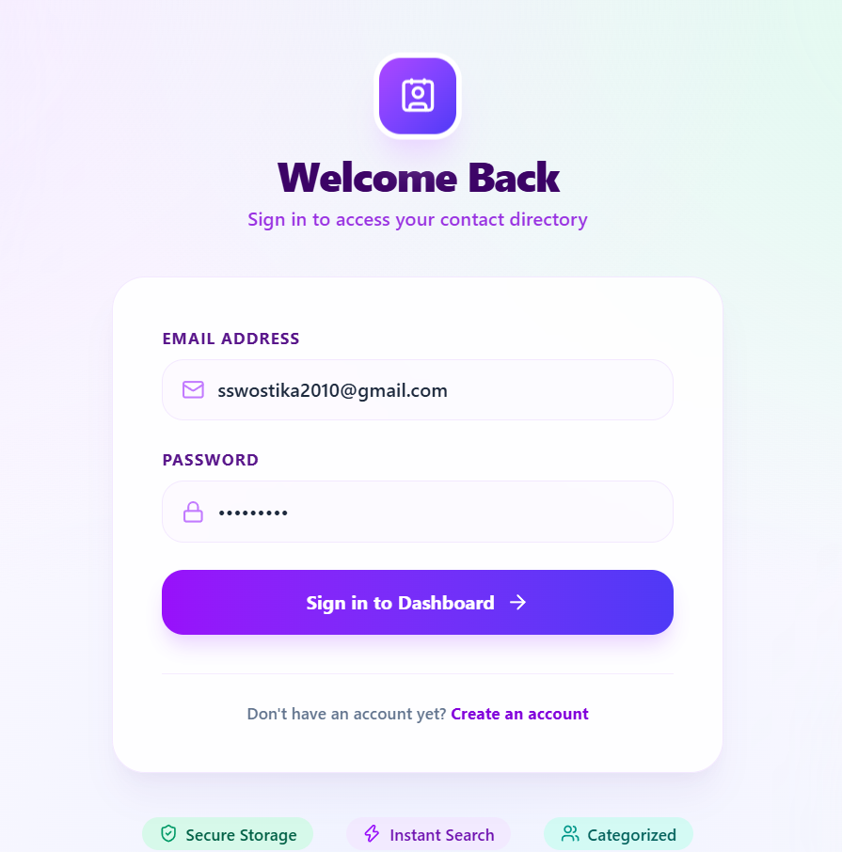

3.1.2 Sign-up Page
The Signup Page allows new users to create an account. The page contains a full name field, an email address field, a password field, a Create Account button, and a link back to the Login Page.  When the user submits the form, the frontend sends the name, email, and password to the backend. After successful registration, the backend creates the user account and establishes an authenticated session, and the frontend redirects the user to the dashboard. | 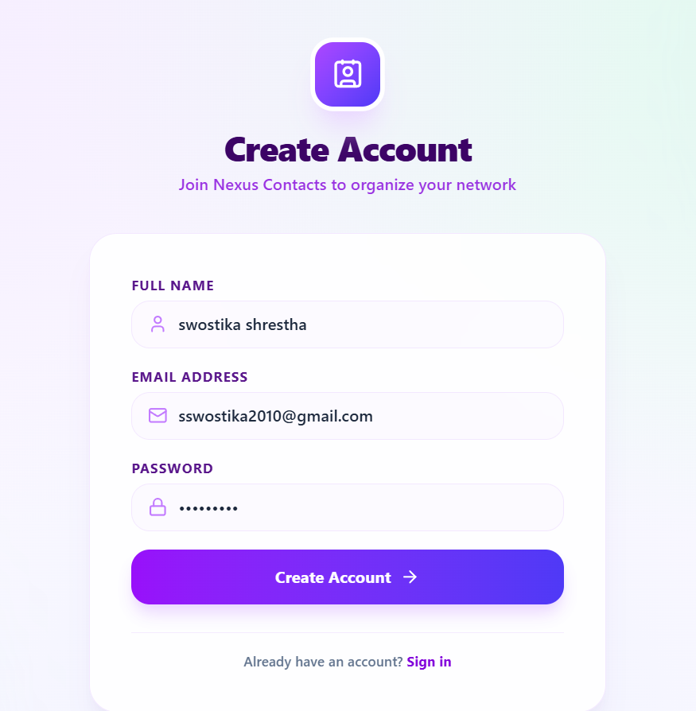

3.1.3 Dashboard Page
The Dashboard is the main interface of the Contact Manager. It allows authenticated users to manage their contacts from a centralized location. It provides the logged-in user's information, contact statistics, search functionality, category filtering, a contact list, and add / edit / delete actions with avatar and category badges displayed for every contact.
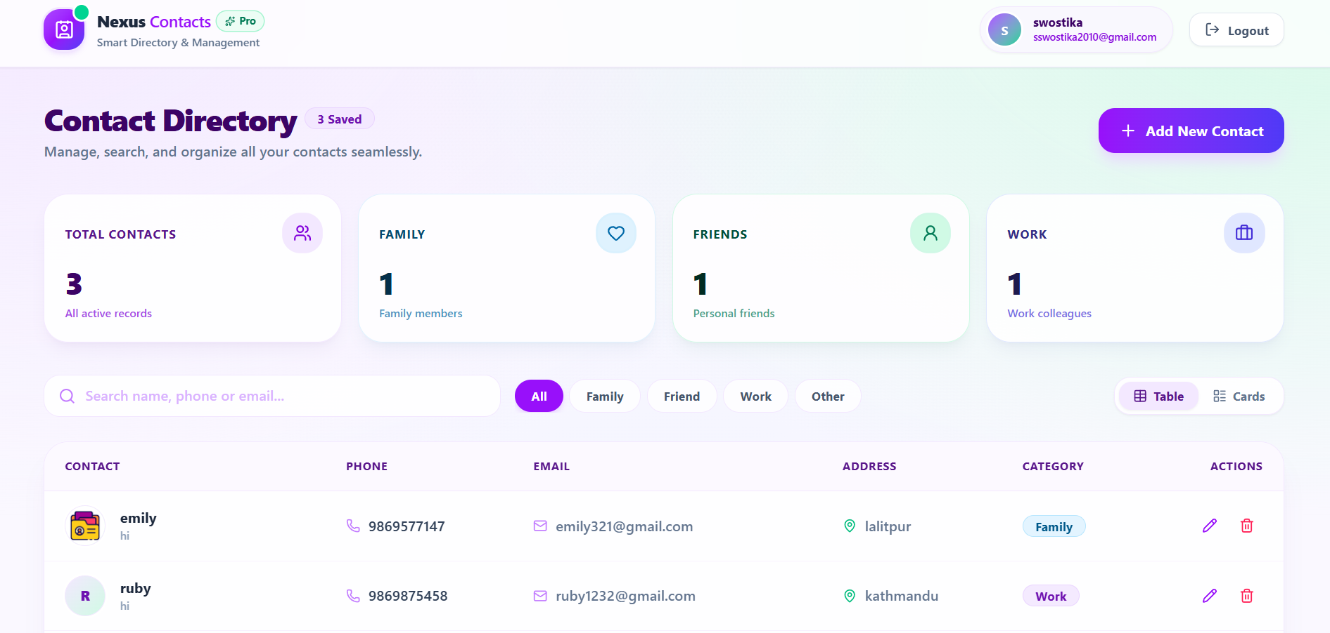

3.1.4 Add Contact
The Add Contact form lets a user create a new record by entering the contact's name and phone number (required), plus email, address, category, notes, and an optional profile photo. Submitting the form sends the data to the backend, which creates the contact for the logged-in user. | 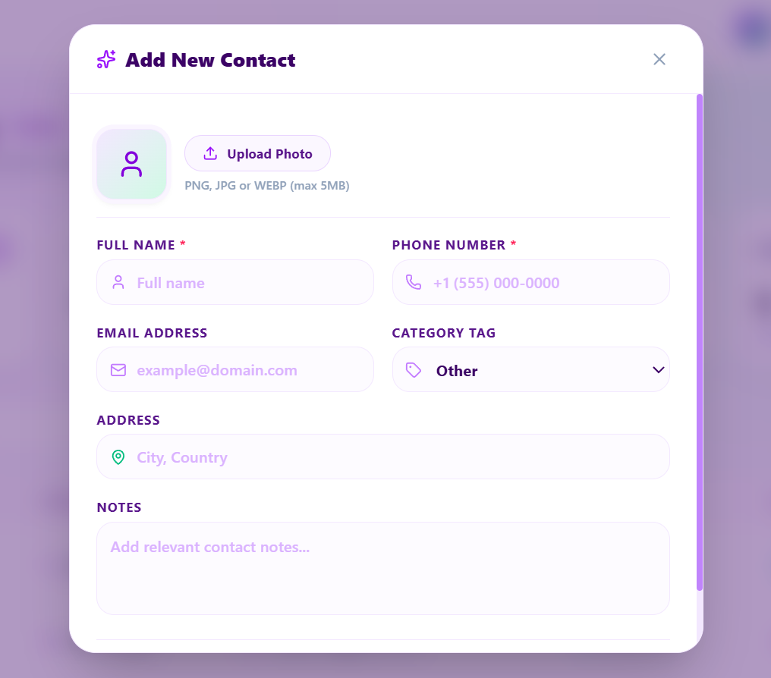

3.1.5 Edit Contact
The Edit Contact modal reuses the same form, pre-filled with the contact's existing details. Users can update any field, including the profile photo, and save the changes with the Update Contact button. | 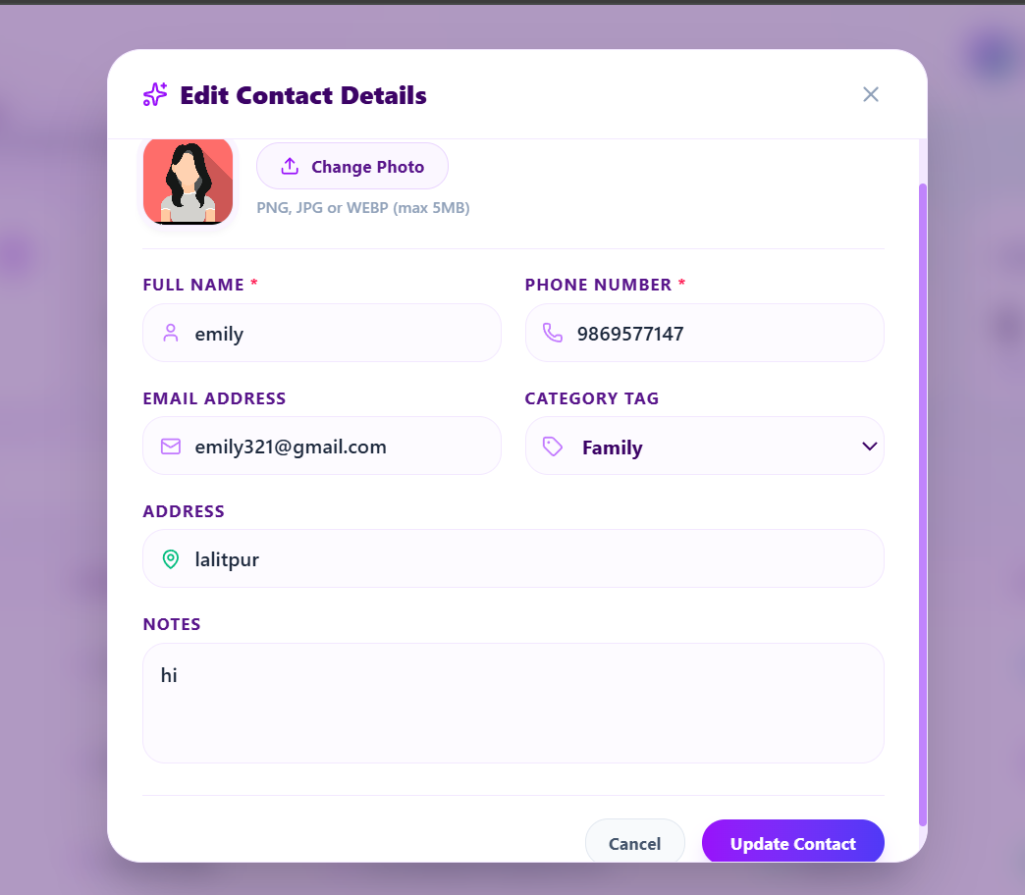

3.2 Main API Endpoints
The backend provides RESTful API endpoints for authentication and contact management. Every contacts endpoint is protected and scoped to the logged-in user.
Method | Endpoint | Description
POST | /api/auth/signup | Registers a new user and starts a session
POST | /api/auth/login | Verifies credentials and starts a session
POST | /api/auth/logout | Destroys the active session
GET | /api/auth/me | Returns the logged-in user, or 401
GET | /api/contacts | Fetches all contacts for the current user
POST | /api/contacts | Creates a new contact
GET | /api/contacts/:id | Fetches a single contact by ID
PUT | /api/contacts/:id | Updates an existing contact
DELETE | /api/contacts/:id | Deletes a contact

POST /api/contacts
Creates a new contact for the currently authenticated user. The endpoint accepts contact information and, optionally, an avatar image. Name and phone are required; all other fields are optional.

GET /api/contacts
Retrieves all contacts associated with the currently authenticated user. The backend uses the session's user ID to ensure that users only receive their own contacts.

GET /api/contacts/:id
Retrieves a specific contact using its MongoDB ID. The backend checks the authenticated user's ID so that one user cannot access another user's contact.

PUT /api/contacts/:id
Updates an existing contact's name, phone, email, address, notes, category, or avatar. If a new avatar is uploaded, the backend replaces the previous one.

DELETE /api/contacts/:id
Deletes a contact from the database. If the contact has an uploaded avatar, the associated image file is also removed from the server.

SECTION 4

Conclusion
The Contact Manager successfully demonstrates the development of a full-stack web application using modern web technologies.
The system provides essential contact-management functionality, including user authentication, contact creation, viewing, searching, updating, and deletion. It also supports categorization and avatar uploads, making contact information easier to organize and identify.
The project demonstrates the integration of a React frontend, an Express/Node.js backend, and a MongoDB database through RESTful APIs. Authentication and protected routes ensure that users can manage their own contacts while maintaining strict separation between different users.
Overall, the project provides practical experience in frontend development, backend API development, database management, authentication, file handling, CRUD operations, and responsive user-interface design.
Future improvements could include cloud-based image storage, email verification, password recovery, contact import/export, contact sharing, mobile support, and deployment to a production environment.

SECTION 5

References
- React documentation — https://react.dev
- Express.js documentation — https://expressjs.com
- MongoDB documentation — https://www.mongodb.com/docs
- Mongoose documentation — https://mongoosejs.com
- Tailwind CSS documentation — https://tailwindcss.com
- lucide-react icon library — https://lucide.dev
- MDN Web Docs — https://developer.mozilla.org

